**Food Mine**

https://www.youtube.com/watch?v=Uci0L4k3TQo&list=PLpaspowtqj-dA0cRZ1yEZBv0iwdOru-SC&index=3&ab_channel=CodeWithNasir

|  |  |
| --- | --- |
|  | ##  Lessons |
| 2 | 1. Introduction to the course |
| 3 | 2. Install development tools |
| 4 | 3. Create Angular App |
| 5 | 1. Create project's folder |
| 6 | 2. Install @angular/cli |
| 7 | 3. Create App as frontend |

Instalando

*Npm install -g @angular/cli*

*Ng new frontend -–skip-tests*

*Ou*

*sudo npm install -g @angular/cli@13*

*Ou*

INSTALAR LOCALMENTE *sudo npm install @angular/cli@13*

*Npm install*

Criar past front end

*ng new frontend - -minimal*

*Y Y CSS*

*Cd frontend*

*Ng serve -o ou npm start*

|  |  |  |
| --- | --- | --- |
|  | 4. Add Header 9 | 1. Generate Component |
| 10 | 2. Add Html |
| 11 | 3. Add Css |

*Ng g c components/partials/header*

Usar dois terminais para garatinr que um rode o codigo, e outro para commandos.

*Importando header no* app.component.html

|  |  |
| --- | --- |
|  | 5. List Foods |
|  | 1. Create Food model |
|  | 2. Create data.ts |
|  | 1. Add sample foods |
|  | 3. Add images to assets |
|  | 4. Create Food service |
|  | 5. Create Home component |
|  | 1. Add ts |
|  | 2. Add html |
|  | 3. Add |

1

2

Import iamges

*ng g s service/food*

*cmd + .*

*5*

*ng g c components/pages/home*

Instalar *npm install ng-starrating –force*

Importar em app modules

6. Search

1. ﻿﻿﻿Add method to Food service
2. ﻿﻿﻿Add search route
3. ﻿﻿﻿Show search result in Home component
4. ﻿﻿﻿Generate search component
5. ﻿﻿﻿Add to home component
6. ﻿﻿﻿Add ts
7. ﻿﻿﻿Add html

﻿﻿﻿Add css

1

2

3

4

*ng g c components/partials/search*

8. Food Page

1. ﻿﻿﻿Add method to food service
2. ﻿﻿﻿Generate Food Page component
3. ﻿﻿﻿Add Route
4. ﻿﻿﻿Add ts
5. ﻿﻿﻿Add html

﻿﻿﻿Add css

5

*ng g c components/pages/food-page*

*4*

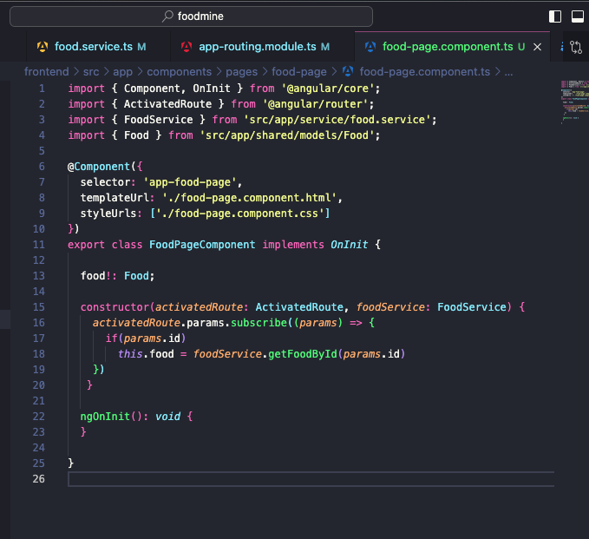

7. Tags Bar

|  |  |
| --- | --- |
|  | 1. Create Tag model |
|  | 2. Add sample tags to data.ts |
|  | 3. Food service |
|  | 1. Add get all tags method |
|  | 2. Add get all foods by tag method |
|  | 4. Add tags route |
|  | 5. Show tag result in Home component |
|  | 6. Generate Tags component |
|  | 1. Add to home component |
|  | 2. Add ts |
|  | 3. Add html |
|  | 4. Add css |

*31 32*

*ng g c components/partials/tags*

*8*

*Cart Page*

*1. Create CartItem Model*

*2. Create Cart Model*

*3. Generate Cart service*

*4. Add to Cart Button in Food Page*

*5. Generate Cart page component*

*1. Add Route*

*2. Add ts*

*3. Add html*

*4. Add css*

*1*

*2*

*3*

*ng g s service/cart*

[*https://www.youtube.com/watch?v=mLqBQVexy0c&list=PLpaspowtqj-dA0cRZ1yEZBv0iwdOru-SC&index=8&ab_channel=CodeWithNasir*](https://www.youtube.com/watch?v=mLqBQVexy0c&list=PLpaspowtqj-dA0cRZ1yEZBv0iwdOru-SC&index=8&ab_channel=CodeWithNasir)

Carrinho de compras - DIFICL

*4*

*ng g c components/pages/cart-page*

